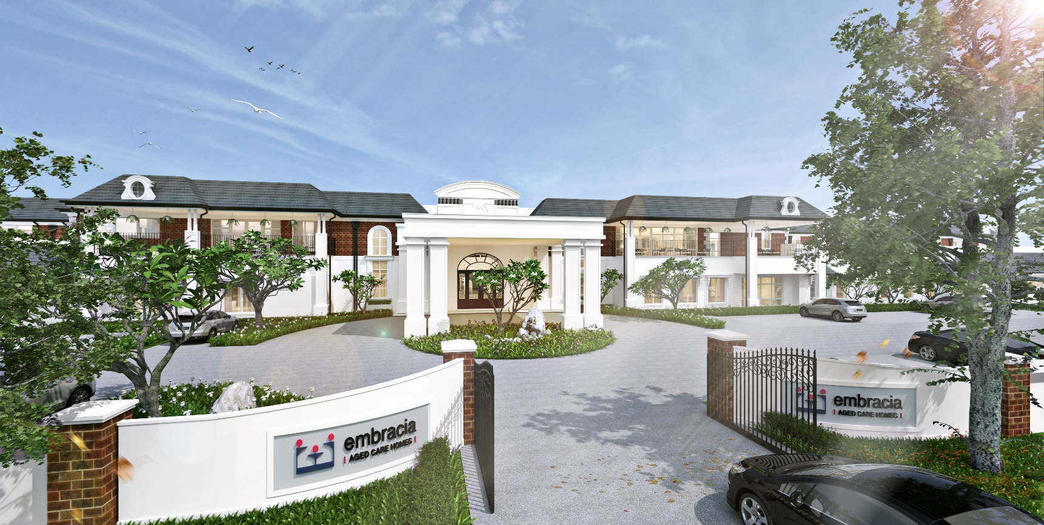
Moonee Valley Newsletter
Il Moonee Valley Mensile
January 2018
Embracia Moonee Valley
76-86 North Road, Avondale Heights Victoria 3034
ph 03 8579 4800
e mooneevalley@embracia.com.au
w www.embraciavic.com.au

Greetings from the Lifestyle Team
Greetings and welcome to Embracia Moonee Valley’s first 2018 Newsletter. Mid to late December 2017 was full of Christmas festive activities. Everything from School Choir performances, Festive Church Services and Mass, Cooking Groups, Art & Craft sessions where decorations were made, Christmas Raffles, Celebratory Happy Hours, Bunnings Christmas Workshop and the much anticipated Residents and Friends Christmas Barbecue was held on Saturday the 9th of December 2017. Residents and relevant others celebrated Christmas in the Carbine Café and outdoors. The turnout was phenomenal and everyone was in great spirits.
Thank you to the staff who gave their time to ensure that these events were a great success. A special thank you to the students doing placement, Embracia volunteers and staff who volunteered their time to make the Christmas Barbecue remarkable and memorable. There were over 300 guests, including residents and everyone had a jolly time.
Furthermore, Embracia Moonee Valley has introduced Exercise/Physio classes. These will be held every Monday morning in the Exercise room with Karina (Physiotherapist) at 11.00 am starting in February 2018. Residents may also make arrangements with Karina to have 1:1 sessions with her. Embracia is thankful to Karina for her time and expertise. She is a valued member of our staff.
Lifestyle staff hope that everyone had a Merry Christmas and may you all have a Prosperous and Joyous 2018. Thank you for making the Lifestyle Team feel so valued and for your positive feedback.

Keep in touch!
If you would like to keep up to date with events and activities in our homes, please follow us on Facebook and LinkedIn. Here we provide weekly posts and share fun photos of our residents enjoying the various lifestyle activities on offer.
www.facebook.com/embracia
www.linkedin.com/company/3674144/

December Lifestyle Events
On December the 9th 2017, Embracia held its first Residents and Friends Christmas barbecue. It was an amazing day! The weather was exceptional, the entertainment was great, the food prepared by the Kitchen staff was fantastic. Santa even made an appearance and shared the Christmas Love.
At this time we also reflect on the residents who have passed away in 2017. They will always remain in our memories.
In 2018, we plan to continue our commitment to providing quality of life to our Residents with outings, staying connected to the outer community and building new relationships through our intergenerational programmes.

HAPPY NEW YEAR AND MAY YOU HAVE A PROSPEROUS 2018 FROM EVERYONE AT EMBRACIA MOONEE VALLEY.

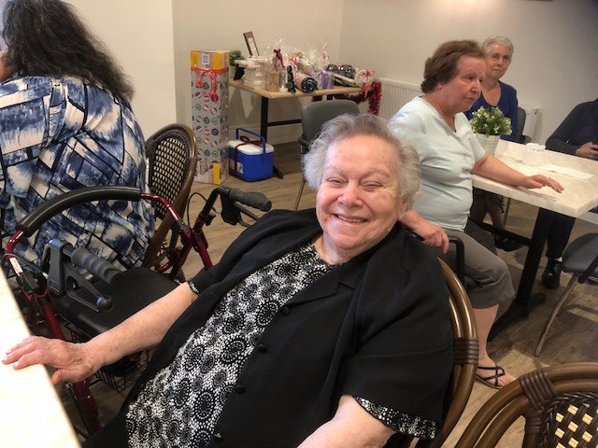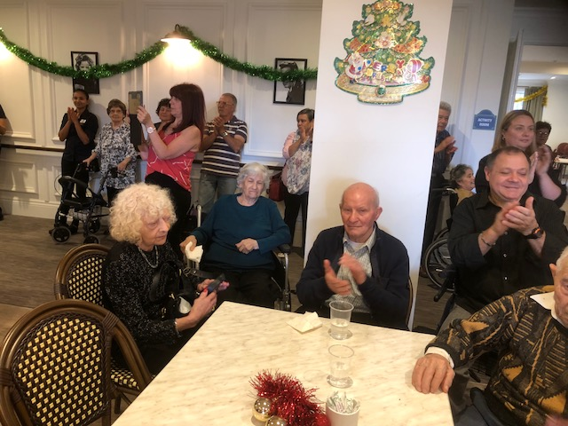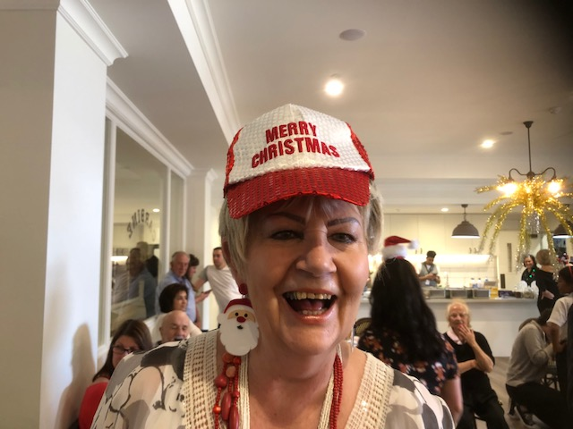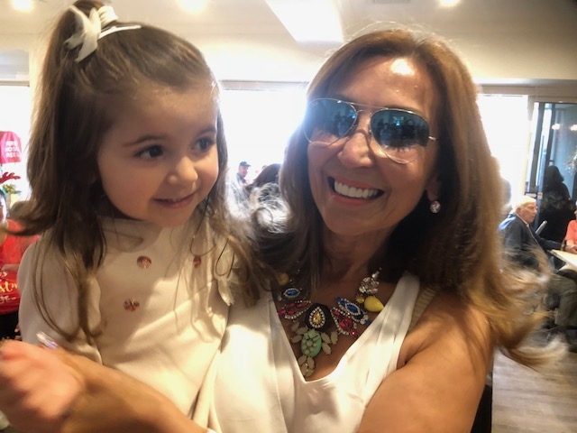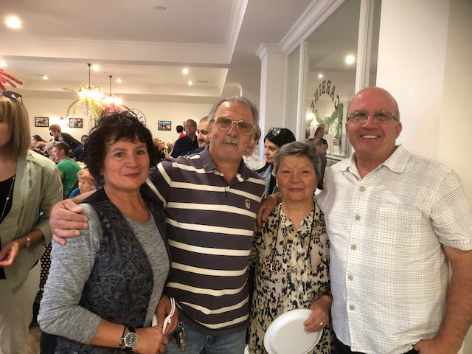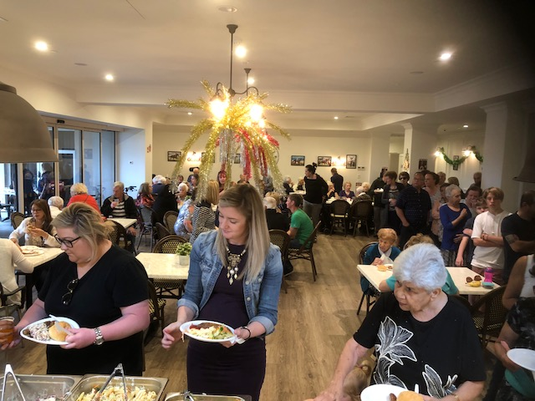
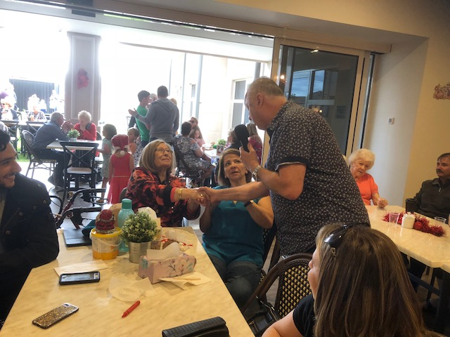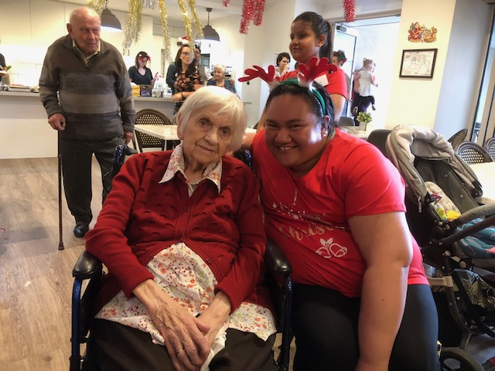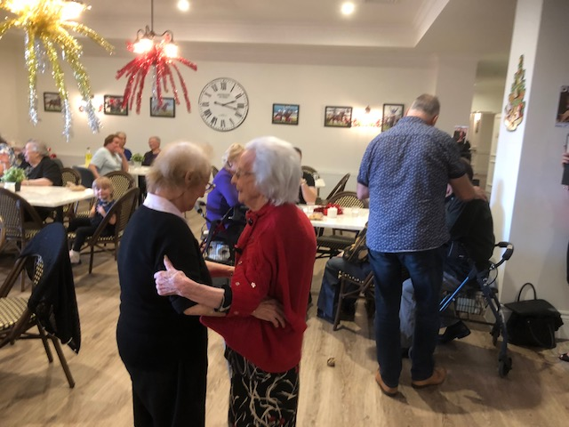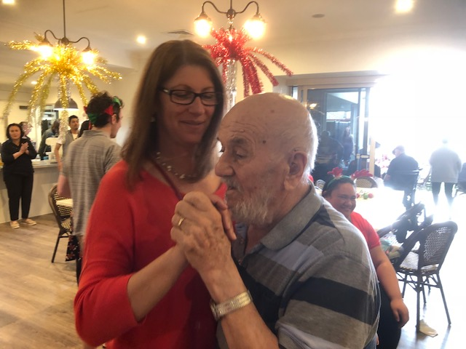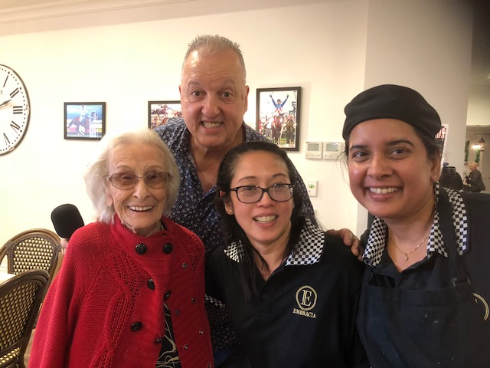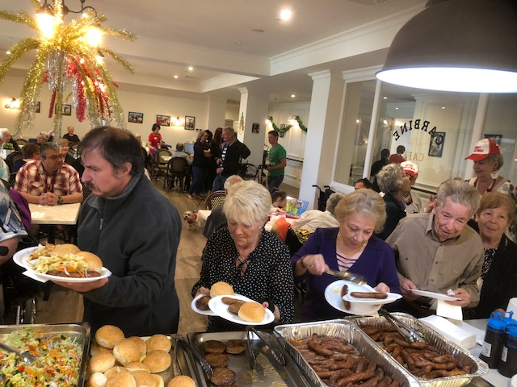

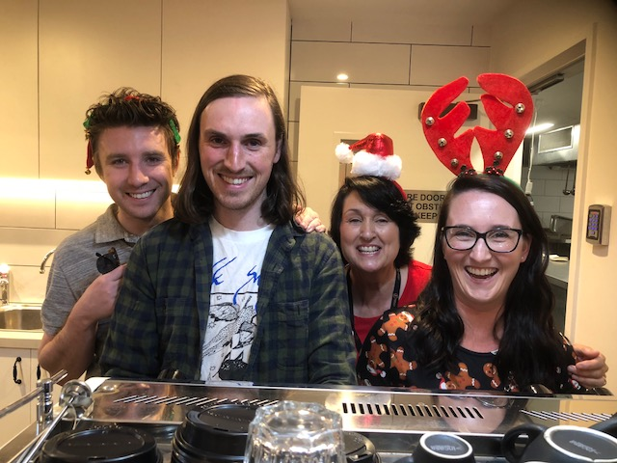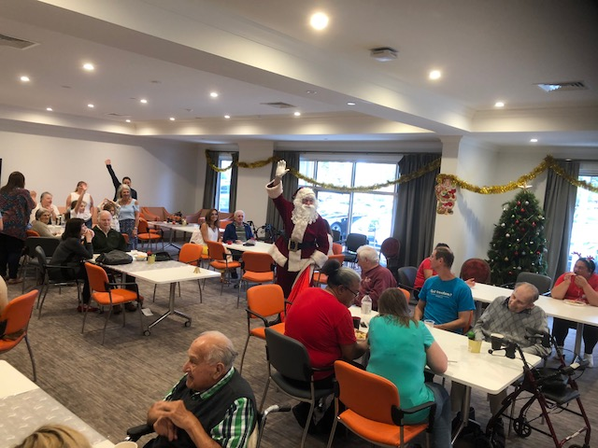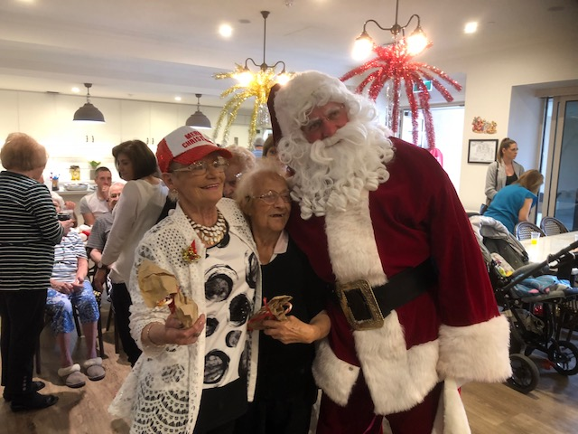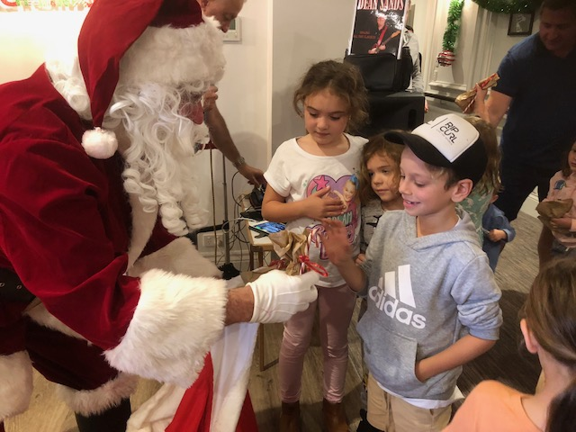

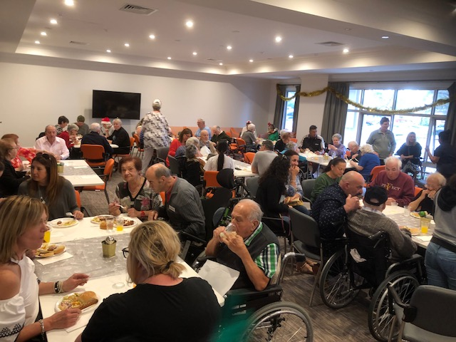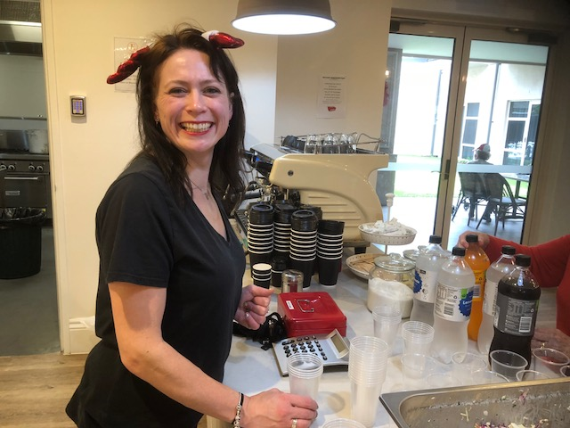

December-January Lifestyle Events
There have been a variety of exciting activities scheduled at Embracia Moonee Valley. Mid December 2017 to mid-January 2018 has been no exception. Part of Embracia’s ‘connecting communities’ initiative is our ongoing partnership and collaboration with Bunnings in Maribyrnong. On the 21st of December, Bunnings held a Christmas workshop where lanterns were constructed and decorated by our residents. The lanterns were lit with gorgeous multi-coloured lights. Everyone was quite proud of their workmanship! There was much chatter, information and story sharing, laughter and overall enjoyment. Residents also enjoyed the company of family members making the workshop more exceptional. The Activity Coordinator, Jenene from Bunnings is committed to providing amazing monthly workshops for our residents. Embracia is thankful to Bunnings for their support, donations and providing quality of life to our residents.
Santa also made a special appearance throughout the month of December having photos with our Residents and sharing some festive joy. These special events brought smiles to our residents’ faces. They were are able to enjoy themselves in a group setting and sharing these moments with each other within their own community.
Residents also enjoyed a ‘Doll Therapy’ session. Bethany, who makes the lifelike dolls, will continue to visit Embracia throughout 2018. Doll Therapy is a great therapy for residents especially those living with dementia. It allows for relaxation and brings out the instinctual nurturing side of a person regardless of their cognitive capacity. Even our staff members enjoyed this session, cooing and cradling the dolls like a real little person!
Embracia’s Eden Philosophy is to provide a great human experience for our residents. To combat the potential ‘3 plagues’ of an older person’s existence. Namely, to overcome Loneliness, Helplessness and Boredom by providing a social environment that values the human spirit. It is of paramount importance to the Lifestyle Team to offer our residents activities of choice and interest to them. To enable choices as per person centred approach and also to be culturally sensitive to everyone’s needs.

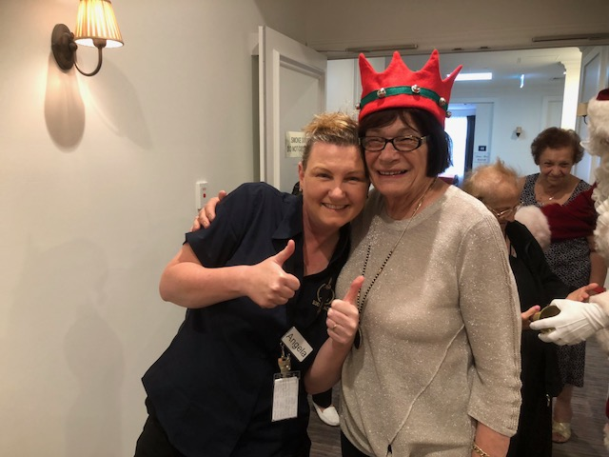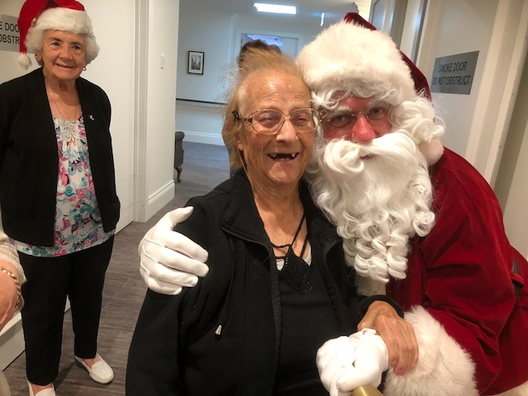
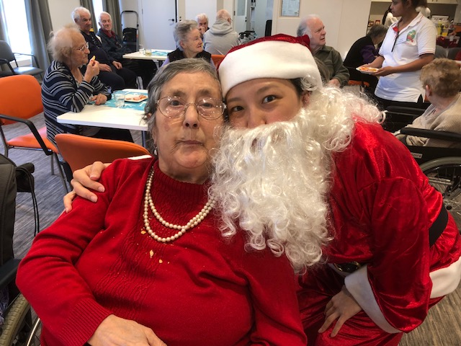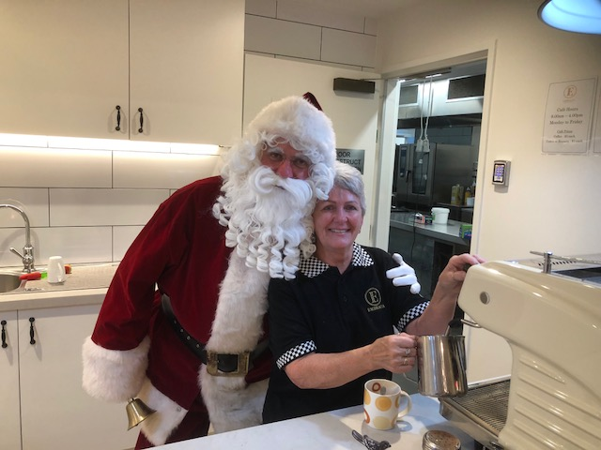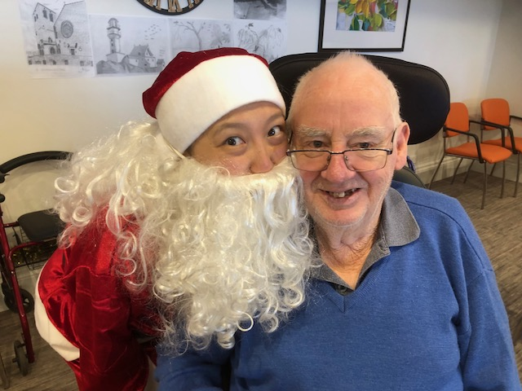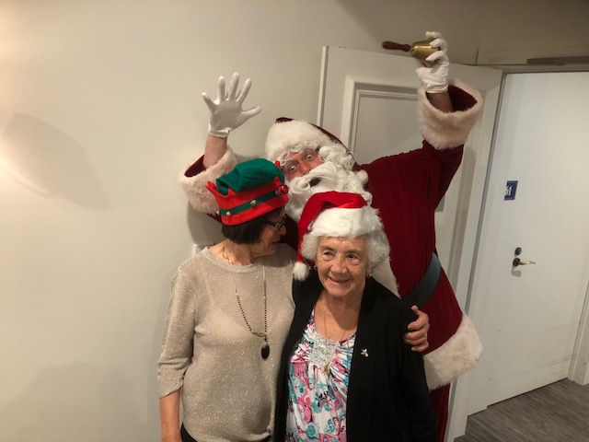

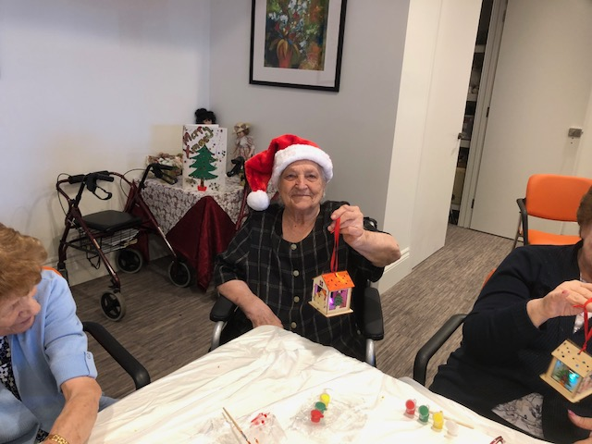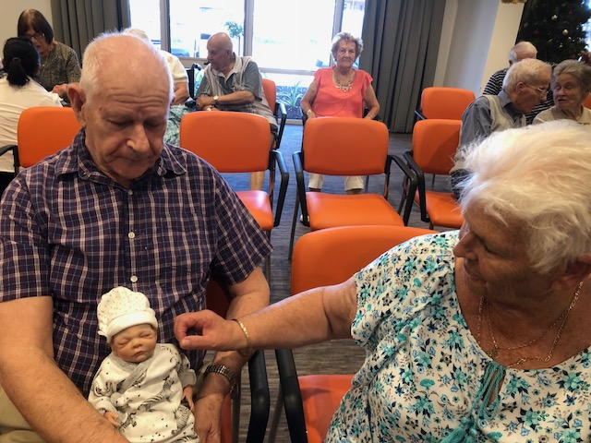
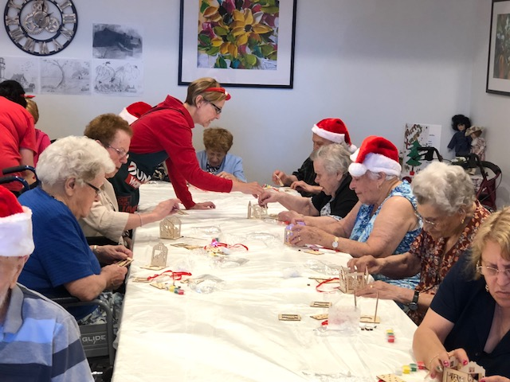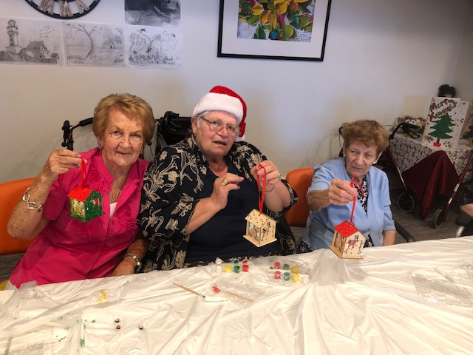
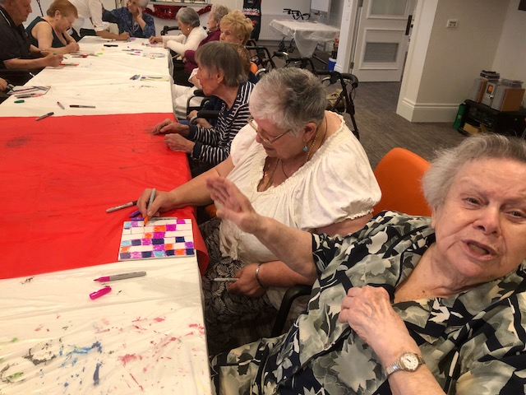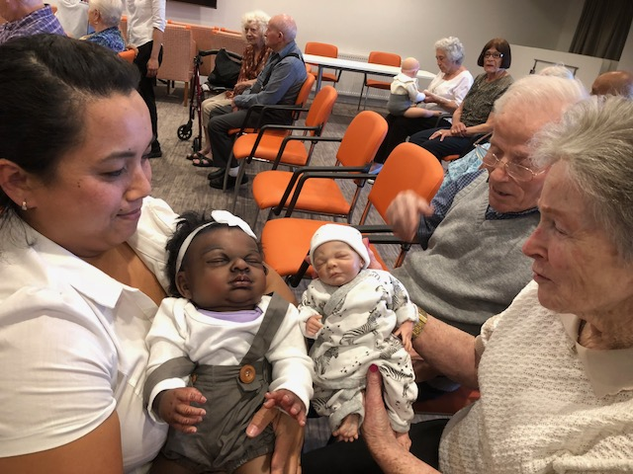

From the Management Team
Thank you to all the families and friends who attended our Christmas BBQ. It was a joyous event and the weather was great too. It truly was exciting to see our residents and families mingling happily with others. We appreciate you coming on the day to celebrate our first Christmas BBQ so thank you from all of us at Embracia.
A Team from the Quality Agency will visit the home on 22nd January to 23rd January to assess quality of care. You can talk to the surveyors and be assured your conversation will be confidential. To complete their assessment and prepare their report the surveyors will also interview management and staff, review records and documents and observe care delivery and physical surroundings. Please see us if you have any queries in regards to the visit.

Birthdays

December January
Michelle – 4th December
Gaetana – 5th December
Maria F – 6th December
Winifred – 3rd January
Rosa – 7th January
Frances – 10th January

Maria C – 14th December Brian – 10th January
Barbara – 18th December Silvana – 15th January
Esther – 30th December Vicki M – 19th January
Ethel – 21st January
Alfredo – 22nd January
Helen – 23rd January
Emine – 25th January
Frank – 26th January
Horace – 27th January
Marcia – 28th January

In Loving Memory
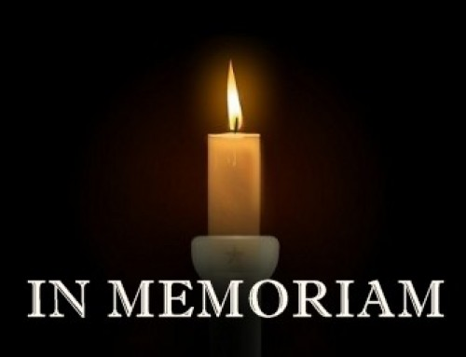

December
Anthony – 25th December

May his memory give his family and friends

the strength to face the days ahead.

Rest in Peace

Riposare in Pace

Upcoming Events

Happy Hour
Every Friday

Activity Room-2:00 pm

Panagia Soumela
Greek Orthodox Church Service
Refer to Calendars for future dates

Chapel-11:00am

Spa & Pampering
4th January

Activity Room-2:00pm

Church Service
Every Wednesday & Friday

Activity Room-11:00 am

Cooking Group
4th January-Greek ‘Koulouria’

Main Activity Room 11.00am

Milleara Shops Outing
9th January
Milleara Shops-10.45-12.00pm

Men’s Group
11th January
“Living in Australia” Talks

Men’s Lounge 2.00pm
Happy Hour
12th January “Australiana”
Didgeridoo Aboriginal Music

Main Activity Room-2.00pm

Residents Australia Day
Barbecue
25th January

Carbine Cafe-11.00-1.30pm
MCGI Youth Choir
27th January-“Karaoke Style”

Main Activity Room

Australia Day
Public Holiday
26th January

No Lifestyle
Queen’s Park Outing
30th January
Queen’s Park-Moonee Ponds

STAFF MEMBER’S FIVE MINUTES OF FAME
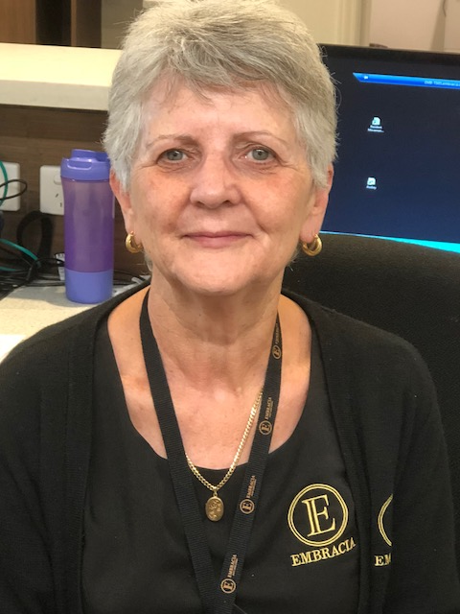
\
INTRODUCING STAFF MEMBER HELEN M

I was born and raised in Reservoir. I got married to Ian in 1970 when I was 19 years of age. I have lived in Bundoora for 30 years and have 4 kids and 10 grandchildren. I have holidayed in Queenscliffe all of my childhood and adulthood.
I have been with Embracia since 1990. Initially, as a PCA and then as an administrative manager. I love working with the elderly and aged care. It has always been my passion.
I enjoy dancing, especially rock n roll and going out for dinner with my friends.
My pet hates are I dislike being bored and enjoy keeping busy. I love to work.
Something we don’t know about you-
I take my 9 grandchildren away to the beach for a holiday every Christmas which I love.

