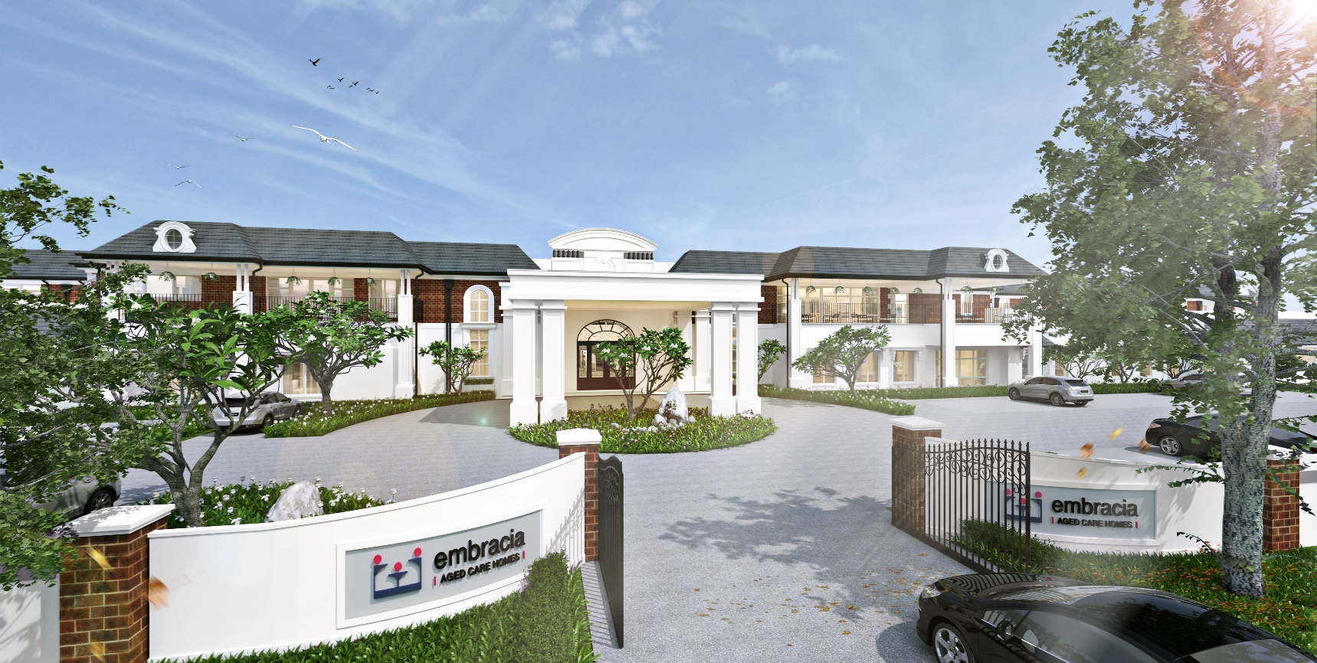
Moonee Valley Newsletter
Il Moonee Valley Mensile
November 2017
Embracia Moonee Valley
76-86 North Road, Avondale Heights Victoria 3034
ph 03 8579 4800
e mooneevalley@embracia.com.au
w www.embraciavic.com.au

Greetings from the Lifestyle Team

Welcome to the Shop ‘til you drop November newsletter. As mentioned in the last newsletter, there will be many shopping sprees at Embracia throughout the month, allowing residents, family members and staff to do some Christmas shopping or merely spoil themselves!
9th November Senior Sales with Steve – clothing sale
13th November - Olli May Women’s clothing
23rd November - Jillian’s Comfort Shoes Sale
30th November - Fifth Avenue Sale with Anne – bags, scarves, jewellery
It is important that Residents have access to community and corporate organisation. These Mobile shopping sprees are paramount as it caters for people who don’t have the ability to leave their homes and purchase items they require. It is empowering residents to make choices and have access to various services in their own home. In 2018, the Lifestyle Team endeavours to schedule shopping outings enabling residents to join the outer community.
Embracia will be commemorating Remembrance Day on Friday the 10th of November. The service will be carried out by Reverend Mark Dunn from the Simpson Barracks in Macleod.

Keep in touch!

If you would like to keep up to date with events and activities in our homes, please follow us on Facebook and LinkedIn. Here we provide weekly posts and share fun photos of our residents enjoying the various lifestyle activities on offer.
www.facebook.com/embracia
www.linkedin.com/company/3674144/

October Lifestyle Events

The National Gallery of Victoria held a “Dior Exhibition” at Embracia Moonee Valley on Thursday the 19th of October at 2.00 pm in the Activity Room. There will be more exhibitions scheduled for next year on different topics. Once again, Embracia is grateful to Judy, the presenter, for her time and expertise. The Voluntary Guides of the NGV operates with the aim of providing support to the community in understanding and appreciating the NGV and its collections. It provides a link between the NGV and the community and especially caters for individuals that may otherwise not have the opportunity to experience what the Gallery has to offer.
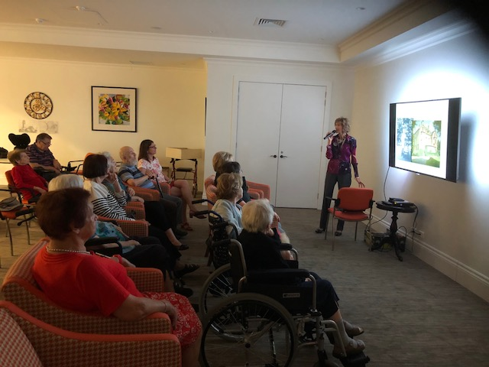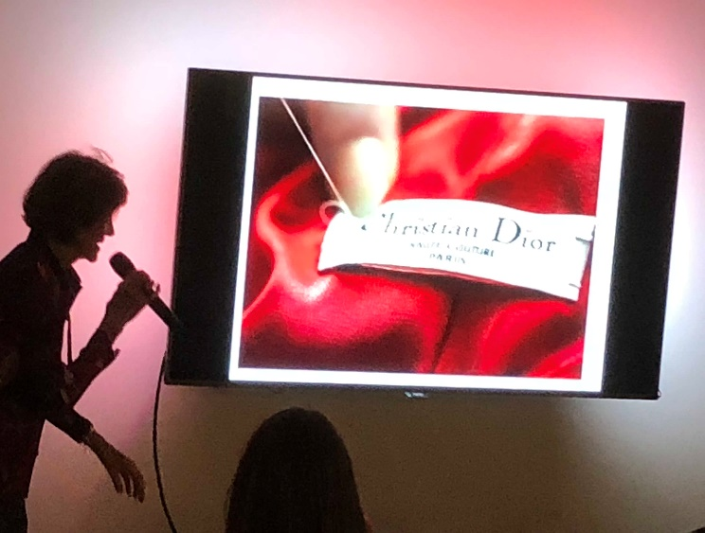
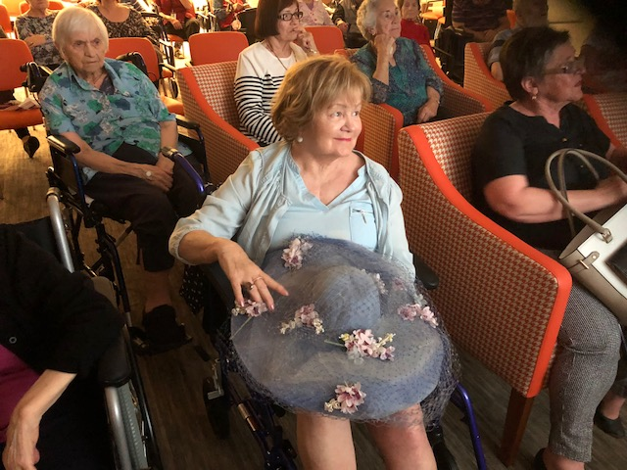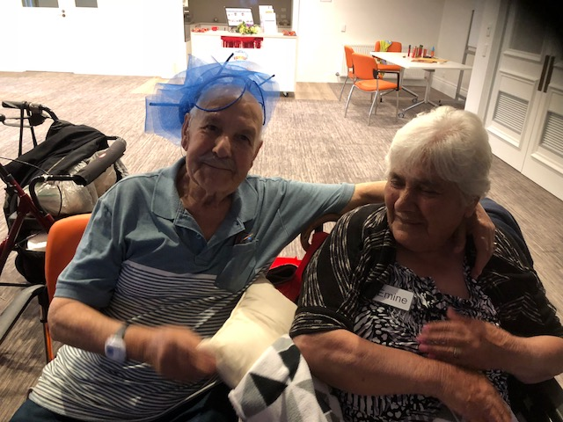
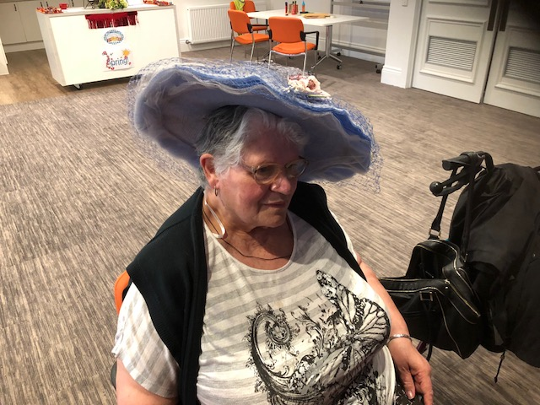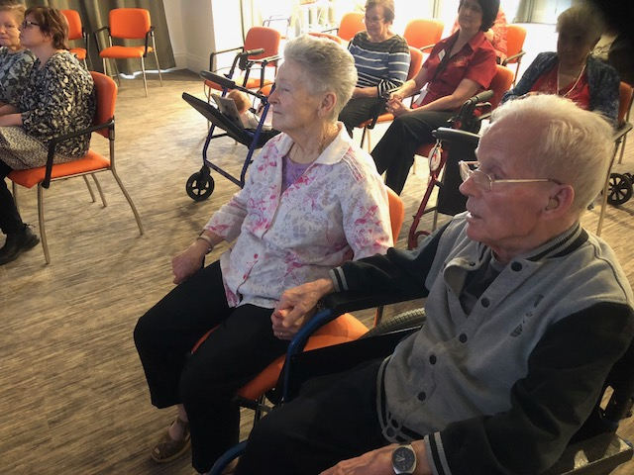
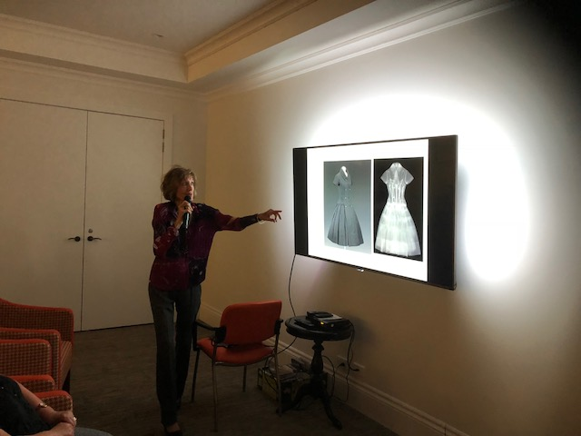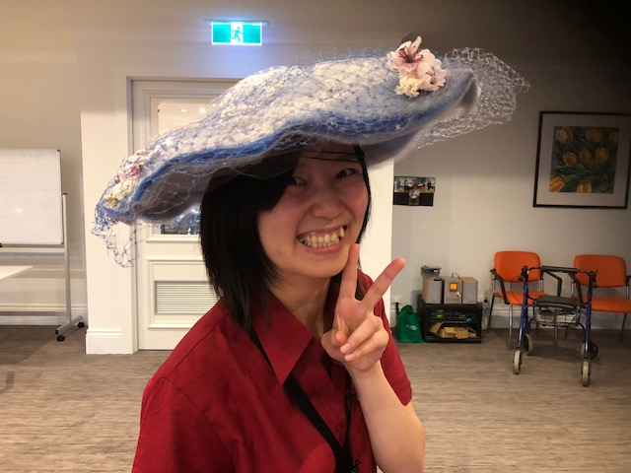
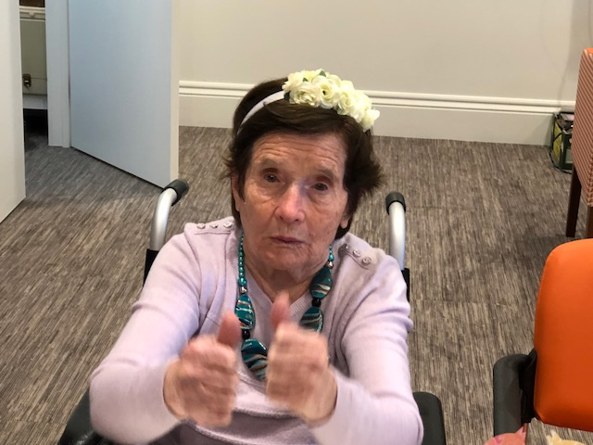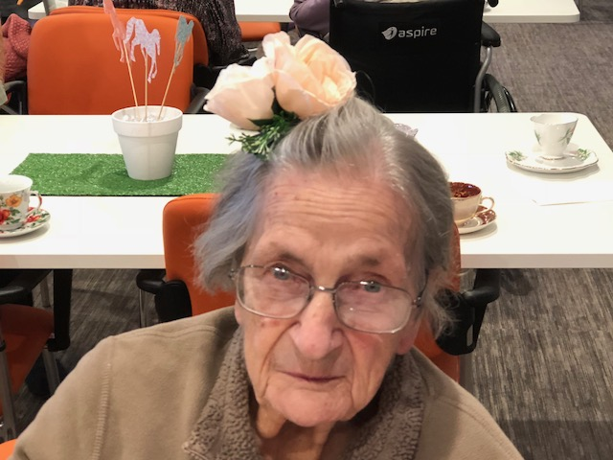

November Lifestyle Events
In the months of October and early November High Teas were held, cooking groups, Art and Craft, Sing A Longs, Church Services every Wednesday and Friday mornings and the much anticipated Happy Hour enjoyed every Friday afternoon. The RSL morning melodies will be an ongoing monthly outing until December. The Lifestyle Team endeavour to take different groups of residents every trip.
Embracia’s residents enjoyed the Bunnings Workshop on the 26th of October. Residents enjoyed making musical instruments from plastic cylinders that they painted using different techniques. Aboriginal dot art was used and different coloured designs of their liking. The cylinders were filled with various pebbles to create a percussion sound. These inventive musical instruments will be used during Sing A Long and music appreciation sessions.
Embracia residents will experience their first Music Therapy session with Dr. Loretta on Friday the 17th of October during Happy Hour in the afternoon. Music therapy is an expressive Intervention which allows residents to improve their mental and physical wellbeing. Music is used to enhance an individual’s physical, emotional, mental, social, aesthetic and spiritual health.
Christmas Barbecue for Residents and Families will be held on Saturday the 9th of December 2017 from 12.00 – 3.00pm in the Carbine café adjacent to the Activity Room. There will be entertainment on the day. Please don’t forget to fill in the form and include number of family members attending for catering purposes.
We will keep you updated on the upcoming Christmas festivities.
On behalf of the Lifestyle Team, we are committed to offering new and exciting events and making activities enjoyable for all. Activities are up and running on the weekends now with Lifestyle Assistant Tina and Embracia volunteer Amilia. Please note, that family members and visitors are welcome to join if they please.
Cheers and enjoy the rest of your November.

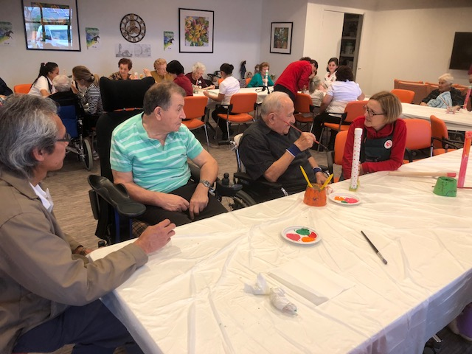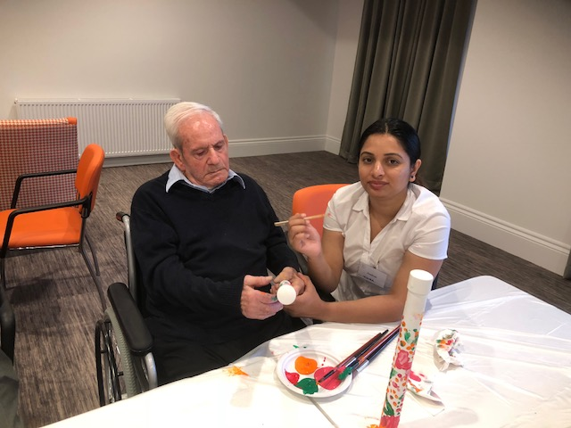
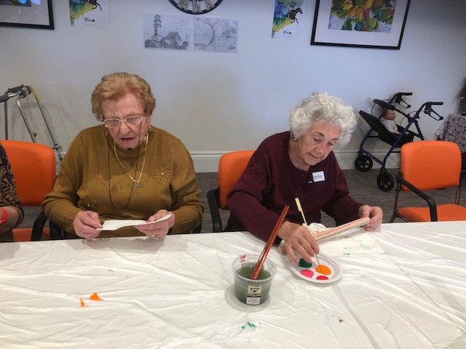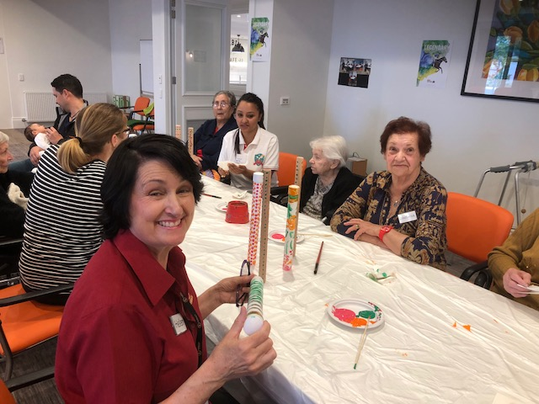
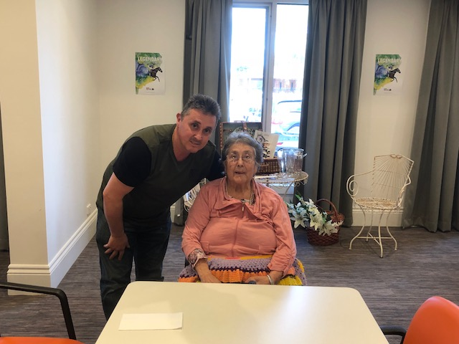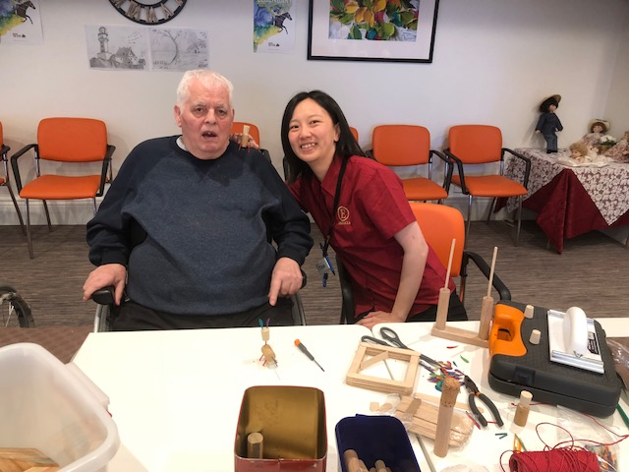

Messages from Management

Thank you to all the residents and families for their understanding when we have to lockdown the home during our recent gastro-outbreak. This measure assisted us greatly in managing the outbreak and ensured the virus did not spread to the rest of the home. A total of 4 residents were affected and recovered quickly thanks to the prompt attention of the staff. The changes in weather bring about different viruses out in the community so please do not visit if you are ill as our residents, due to their age and medical conditions, are vulnerable and their immune system can easily get compromised.
Hairdressing services are provided every Thursday and payment can be made directly to the hairdresser on the day. There is a hairdressing book in the foyer if you wish to book your family member or you may let the staff know.
There is a Pharmacy Box installed on the ground floor just outside the lift. You may lodge any queries you may have in relation to your invoices directly to the Pharmacist in this box.
We value your feedback and any suggestions to improve our delivery of care. Please see the management team or lodge your suggestions in the suggestion box in the foyer.

Birthdays

October
Maria C – 5th October
Pasqualina – 19th October
Visa – 24th October
Mary – 31st October

November
Giusseppe M – 9th November
Dimitrije – 10th November
Slava – 10th November
Gladys – 17th November
Rita – 18th November
Philip – 22nd November
Joan – 23rd November
Joyce – 28th November
Irene – 28th November
Con – 17th November

In Loving Memory

October
Aileen – 29th October

November
Derek – 3rd November
Salvatore – 9th November

May their memory give their families and friends the strength to face the days ahead.

Rest in Peace

Riposare in Pace

Upcoming Events

Happy Hour
Every Friday

Activity Room-2.00 pm

Essendon Keilor College
30th October - Choir Performance

Activity Room-2.00 pm

Remembrance Day Service
10th November-Reverend M. Dunn

Activity Room-2.30pm
Lest We Forget

Church Service
Every Wednesday & Friday

Activity Room-11.00 am
Senior Sales
9th November-Men & Women’s Apparel

Activity Room-2.00-4.00pm

Olli-May Women’s Clothing
13th November
Activity Room-10.00am-1.00pm

Sing A Long with Loretta
17th November-Happy Hour

Activity Room-2.00-3.00pm

Jillian’s Comfort Shoe Sale
23rd November

Activity Room-10.00am-1.00pm

Bunnings workshop
23rd November-Craft Workshop

Activity Room-2.00-3.00pm

Residents & Families Barbecue
9th December

Carbine Café 12.00-3.00pm

Fifth Avenue Sale
30th November-Bags, Scarves, Jewellery and more

Activity Room-10.00-1.00pm

STAFF MEMBERS FIVE MINUTES OF FAME
Angela
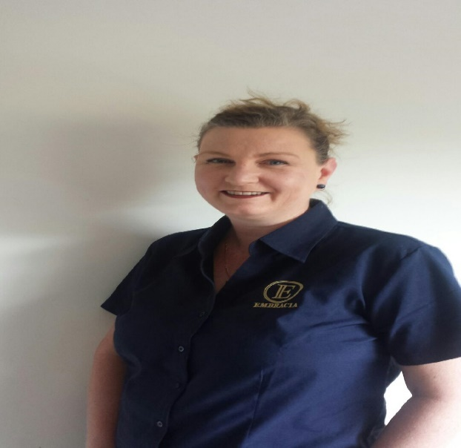
INTRODUCING STAFF MEMBER ANGELA
I was born in Scotland and came to Australia in 1980. I have one sister and most of my family is in Adelaide. I am married and have two children. Emma is 17 and Jayden is almost 14. My husband is in the RAAF and my family has lived in many states due to my husband’s work. I recently moved from England.
I am an Enrolled Nurse and a Team Leader in Tulloch and Northerly Household and I love my job. I have worked in many nursing environments including hospitals, aged care, public and private hospital settings.
My hobby is taking Bella (my pet dog) for walks at dog parks, outings with my family and bushwalking. I also bring Bella to Embracia Moonee Valley for pet therapy.
I don’t have many pet hates. I am easy going and a good team player.
My motto is ‘I am eager and willing to please’.
Maybe I dislike Melbourne’s unpredictable weather.
SOMETHING WE DON’T KNOW ABOUT YOU:
I was born in Scotland and don’t have a Scottish accent unlike my other family members.

