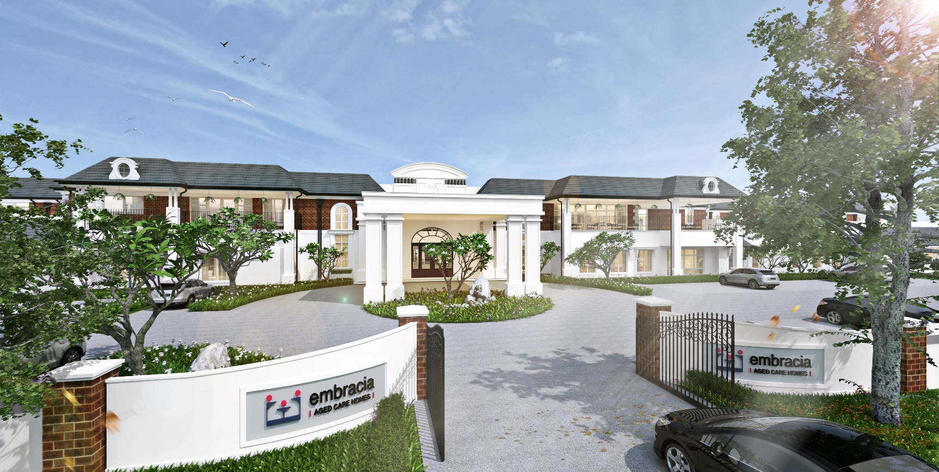
Moonee Valley Newsletter
Il Moonee Valley Mensile
May 2018
Embracia Moonee Valley
76-86 North Road, Avondale Heights Victoria 3034
ph 03 8579 4800
e mooneevalley@embracia.com.au
w www.embraciavic.com.au

Greetings from the Lifestyle Team
Empowering our older citizen and in particular our Residents with options, decision making, keeping them busy is paramount to their overall holistic wellbeing. Specifically, daily activities focus on building relationships, keeping residents engaged-mentally alert and have a sense of purpose. Everyone needs to feel socially connected to maintain physical, spiritual and mental health. Regardless of Cognitive Capacity.
Montessori theory is applied in Memory Support households by staff and family members. It is based on resident’s strengths, interests, needs and abilities. Staff identify cues to assist residents in making choices and taking part in tasks in set up activity stations in each Memory Support households. By knowing our Residents over time, staff is able to determine their interests, existing skills, potential skills and identify any roles that used their skills. Whether it be washing dishes, setting tables, various soring tasks, playing floor games and even assisting staff with trolleys or any other duties. The aim is to use Rehabilitative therapies (tasks) to support procedural memory-stored information on how to perform certain procedures such as walking, talking and even gardening. It’s also creating a new Norm.
Family members and relevant others can also contribute to this as they know their loved one best and may have suggestions on tasks that they may enjoy performing and even assist them with some new ideas. The following links may have some ideas and more information on Montessori for Dementia model of care.
www.dementia.org.au/sites/default/files/20130725_-_Montessori_Booklet_A5.pdf
National Dementia Helpline 1800 100 500 www.fightdementia.org.au

Keep in touch!

If you would like to keep up to date with events and activities in our homes, please follow us on Facebook and LinkedIn. Here we provide weekly posts and share fun photos of our residents enjoying the various lifestyle activities on offer.
www.facebook.com/embracia
www.linkedin.com/company/3674144/

Lifestyle Events
Easter is a special time for many Residents at Embracia regardless of background and faith. During Easter holidays and celebrations elderly relatives can often be forgotten. Various Easter activities held throughout April were an opportunity for family members and relevant others to spend quality time with elderly relatives. There were craft sessions, cooking groups, colouring of Easter eggs, music appreciation, socials, happy hour, Military Early Centre ‘Intergenerational Play Dates’ and movies with an Easter theme. The heart of Easter message is to give to others and to reflect on the importance of family and our seniors who have provided so much for their loved ones.
HAPPY EASTER

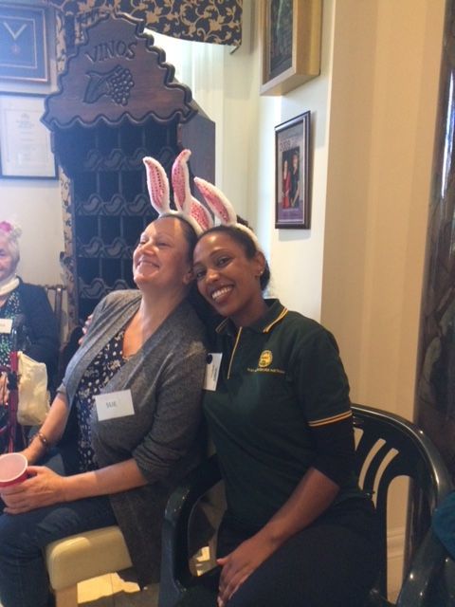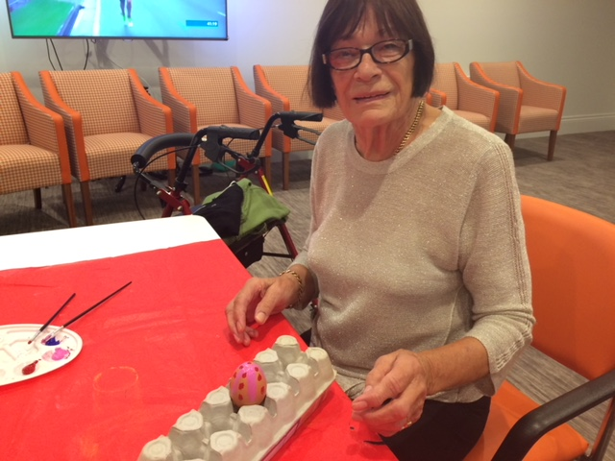
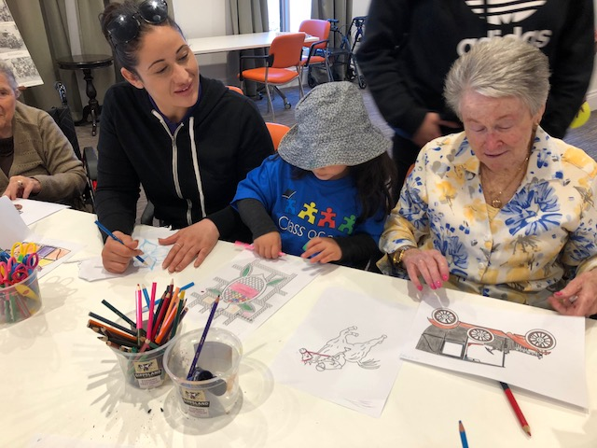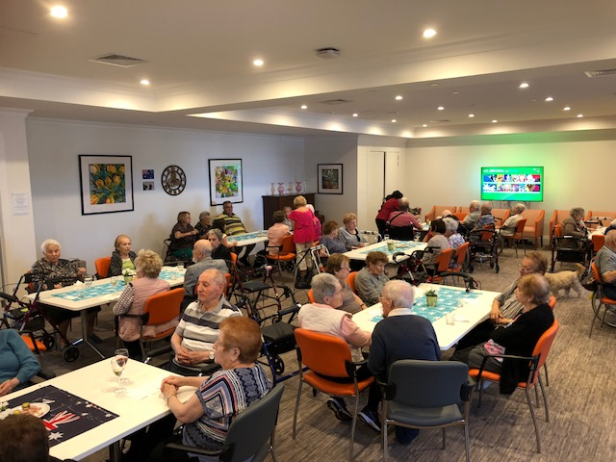
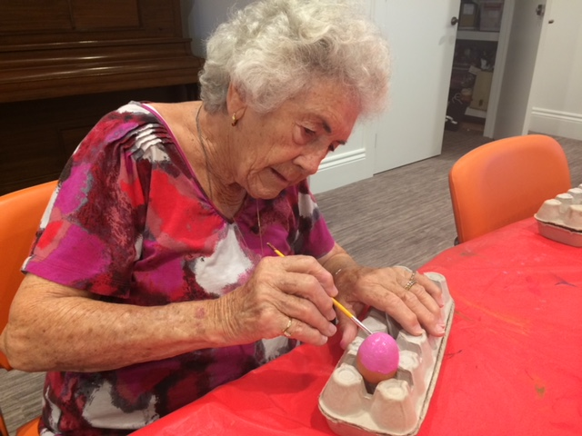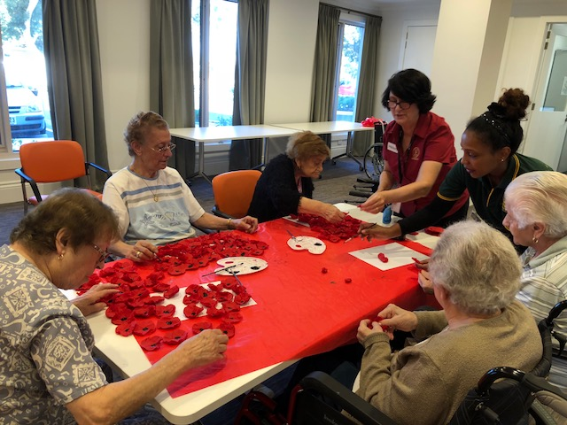

April Lifestyle Events
Anzac Day, 25th April, is one of Australia’s most important national occasions. It marks the anniversary of the first major military action fought by Australian and New Zealand forces during the First World War.
Anzac Day Service was held on the 24th of April at Embracia by Padre Mark Dunn from the Simpson Barracks in Macleod. In honour of the soldiers who fought for our freedom. Residents prayed, listened to the Ode of fallen soldiers, the Reveille and the Last Post, held a minutes silence and sang the National Anthem. Speeches were made by ex-service men and women, who shared their narrative about their time serving their country. It was an emotional service. Verna shared her story as a carer for the service men during WW2. Bruce expressed his sadness and shared fond memories about his time in the Airforce.
It is important to our Residents to commemorate and hold such services, acknowledging and remembering, as many of our Residents and their families were affected by the Wars.

THE ODE
They shall grow not old, as we that are left
Grow old:
Age shall not weary them, nor the years
Condemn.
At the going down of the sun and in the
Morning
We will remember them.
We will remember them.

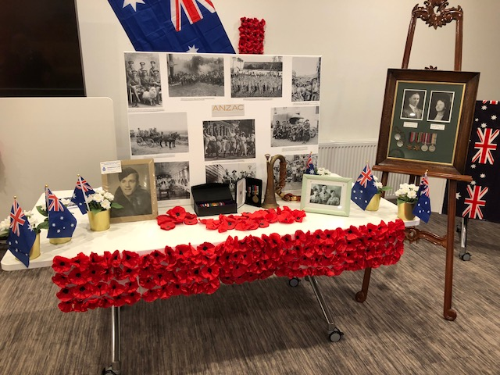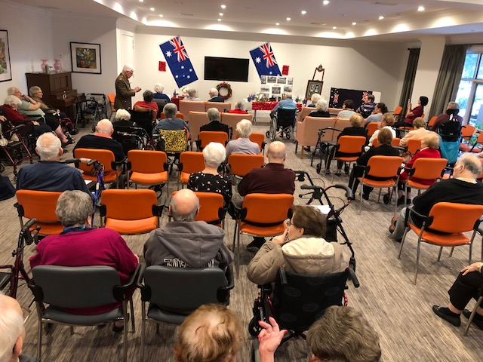
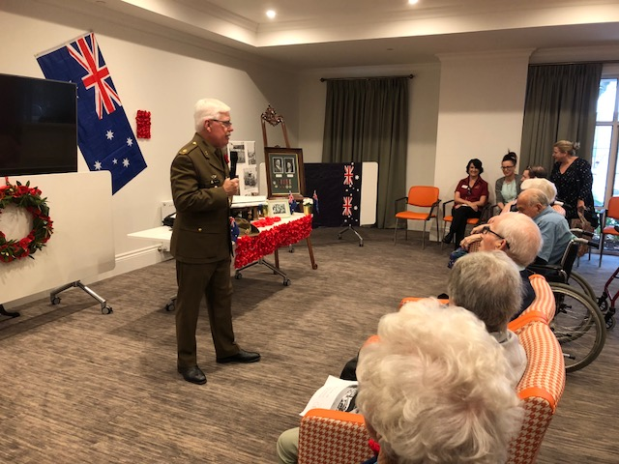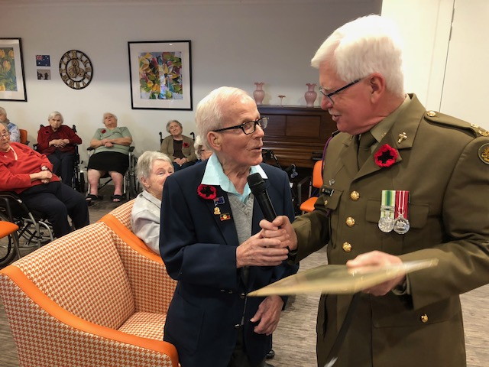
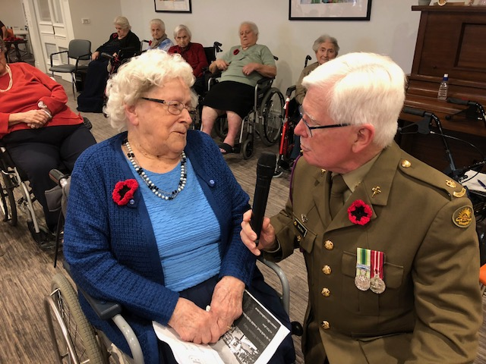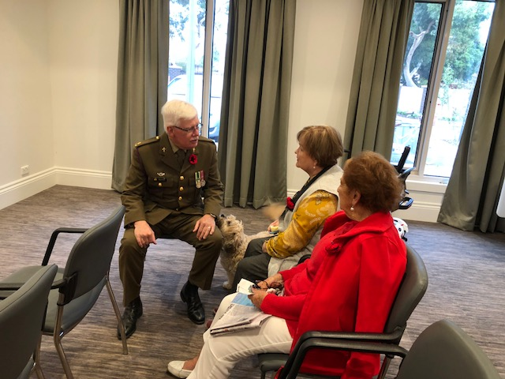

From the Management Team
On the 2nd of May we had Pauline Meaney from the Elder Rights Advocacy present to residents and families on Care Recipients’ Rights, Responsibilities and the advocacy support that ERA can provide. Many items were raised and addressed from the Management team. A follow up meeting with Pauline will be held on Monday 28th of May 2018 at 6.30pm in the Activities Room. All residents, families and staff are welcome.
We always appreciate feedback to further improve our service delivery. Compliments, Complaints, Suggestion forms are available in the foyer. You may either hand it in person to Management or lodge the completed form in the locked box in the foyer. If you wish to speak to us please let us know and we can arrange a day that suits you.
As many of you may be aware, we have introduced our Additional Services Packages. There is no obligation and you can opt in and out as you wish. For further information, please see Catherine at Reception.
Please note that there will be construction work on North Road – Milleara Road to Western end (completion of Amis Crescent – Milleara Road) between Thursday 24th of May 2018 and Friday 25th May 2018 6.00am and 6.00pm.
Finally, Lilian will be returning from leave on Monday 21st of May 2018. It has been a wonderful experience and a great opportunity to meet more families. I will continue to be onsite and follow up on any outstanding issues.
Until next time, all the best and take care.
Miriani

Birthdays

April
Maria P- 2nd April
Vincent – 6th April

Maurice- 8th April
Settimia- 13th April
Carmela-17th April
Sebastiana- 28th April
Christopher- 30th April

May
Magda- 6th May
Giorgio G-10th May
Wilma- 13th May
Carol- 19th May

In Loving Memory

April - May
Alby- 9th April
Rose- 18th April
Wilma- 19th April
Guselba Balbo-10th May
Calcidon Bajada-12th May
Nunziato-13th May
Kenneth-14th May

May their memory give their family and friends the strength to face the days ahead.

Rest in Peace

Riposare in Pace

Upcoming Events

Happy Hour
Every Friday

Activity Room-2:00 pm

Panagia Soumela
Greek Orthodox Church Service
(Priest will inform Lifestyle staff of date)

Chapel-11:00am

Cooking Group
6th May

Activity Room 2.00pm

Church Service
Every Wednesday & Friday

Activity Room-11:00 am

Exercise with Karina
Every Monday, Tuesday & Thursday

Exercise Room 11.00am

RSL Morning Melodies
8th May
East Keilor RSL-10.15-1.30pm

Entertainment with
Phil Galotta
10th May
‘Mother’s Day Theme‘
Activity Room-2.00pm

MCGI Youth Singing Group
12th May
Activity Room-2.00pm
Activity Room- 2.00 pm

Armchair Travel
5th May
‘Gaudi’s Barcelona’

Activity Room 2.00pm

Happy Hour
Mother’s Day Celebration
11th May
Activity Room-Raffle Draw 2.00pm

Airport West Shopping
& Lunch Outing
17th May
Airport West10.00am-1.30pm

Art & Craft
Beaded Jewellery
20th May
Activity Room 2.00pm

Cooking Group
‘Autumn Scones’
15th May
Activity Room-2.00pm
Spa & Pampering
Intergenerational Play Date
17th May
Activity Room-2.00pm

Ladies Autumn High Tea
‘Royal Family Wedding’
Military Road Kinder Visit 21st May
‘Intergenerational Play Date’ Activity Room-2.00pm
Activity Room 2.00pm
Bunnings Workshop Mindful Drawing
‘Jar Decorating’ 26th May
24th May Activity Room 2.00pm
Activity Room 2.00pm
Armchair Travel Residents Meeting
‘Tour of Bavaria’ 29th May 30th May
Activity Room 2.00pm Activity Room 2.00pm

Happy Hour
Birthday Celebrations
1st June
Activity Room 2.00pm

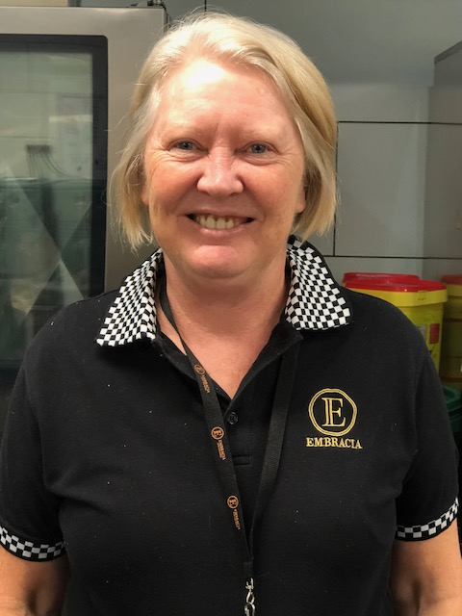

STAFF MEMBER’S FIVE MINUTES OF FAME
INTRODUCING STAFF MEMBER TRACEY
I was born and raised in Frankston. I’m married to Frank and have two adult children. My son is 31 and my daughter is 29. They are both independent and like to travel.
I worked for Safeway for 10 years and have been in Aged Care for 20 years. I worked as a PCA for 18 years and have been with Embracia for about 14 years. Currently I am a cook at Embracia. I love my job and creating different cakes and desserts. It inspires me.
My hobbies are gardening. I love to watch my plants grow. I also love to travel to exotic places.
My pet hates are unorganised people and unclean houses. My motto is:
“Tell the truth and you’ll never be caught out”.
Something we don’t know about you-
I am a LifeSaver.

